The Islamia University of Bahawalpur
Faculty Of Engineering & Technology
Department Of Information & Communication Engineering
Spring 2026

PROJECT REPORT

Windows Disk Image Forensic Investigation & Timeline Reconstruction

Course:CSDF-30117_Introduction to Digital Forensics
Instructor : Engr. Rafia Durani

Submitted by :
Ushna Hidayat ( 4073 M2)
Noor Fatima (4051 M2)

Semeseter : Spring 2026

- Introduction :

In today world cyber crimes like hacking, data breaches, malware attacks and unauthorized access are on the rise. When something happens online it leaves behind clues such as files, logs, browser history and emails. These can be used to investigate crimes .

Digital Forensic is the process of collecting, analyzing and presenting this evidence. Most forensic tools are complicated and can only do one thing making investigations slow and hard.

That’s where ForeniTrace v2.0 comes in. It’s a platform that brings together multiple investigation features in a user-friendly way. ForensiTrace v2.0 helps investigators analyze evidence without needing to be tech experts.

- Project Statement :

Digital forensic investigations involve dealing with types of data at once. Current tools are either too complicated or don’t do enough. We need a system that can :

- Analyze types of evidence in one place with ForensiTrace v2.0
- Automatically detect activities using ForensiTrace v2.0
- Provide simple and clear results from ForensiTrace v2.0
- Generate reports with ForensiTrace v2.0

- Objectives :

- Deveeloped an integrated forensic tools with modules.
- Automate detection of suspicious files and activities
- Provide an easy to use GUI
- Reconstruct timelines from forensic data
- Generate detailed PDF reports
- Visualize result using charts

- System Design :

4.1 Architecture :

The system has 2 parts.

- The first part is GUI layer. It uses something called Tkinter to make it easy for people to use.
- The second part is the analysis engine. It does all the hardwork of looking at the forensic data.

4.2 WorkFlow :

- First we load the evidence. This can be the things like CSV files or logs or even pictures .
- Then we choose which part of the tool we want to use.
- After that the tool will do its job. Look at the evidence.
- When it is done we can look at the results in a table.
- The tool will also make charts and reports, for us so we can see what it found.

- Major Modules
ForensiTrace includes multiple modules for different forensics tasks :
- Timeline Analyzer : This part looks at CSV datta to find activities that seem suspicious.
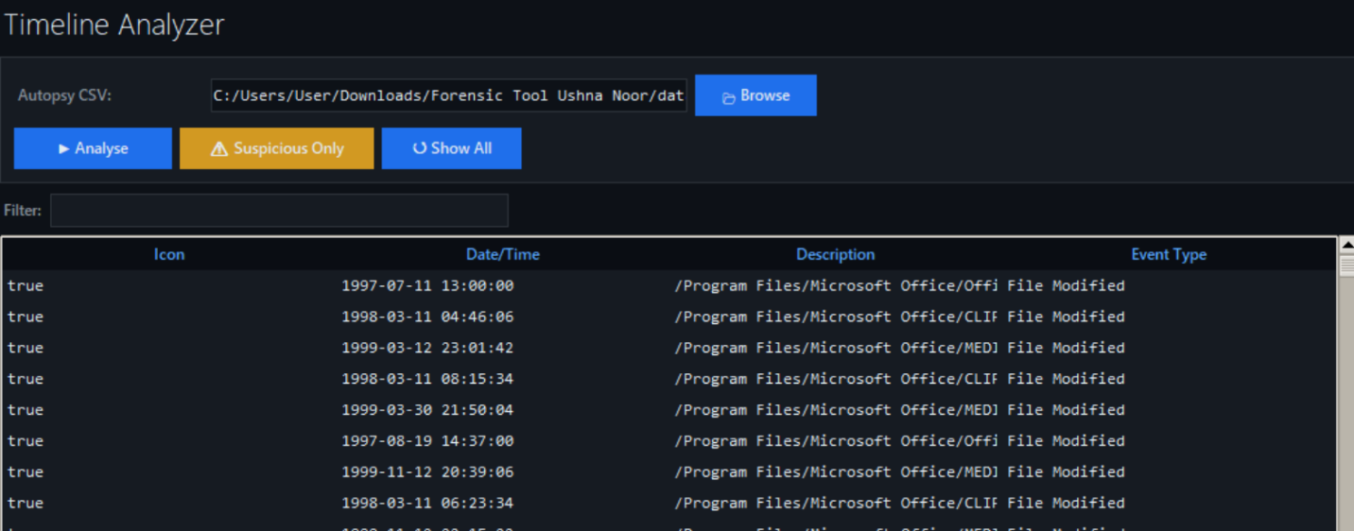

- File & Metadata Analyzer : It gets details about files . Looks at the image EXIF data.

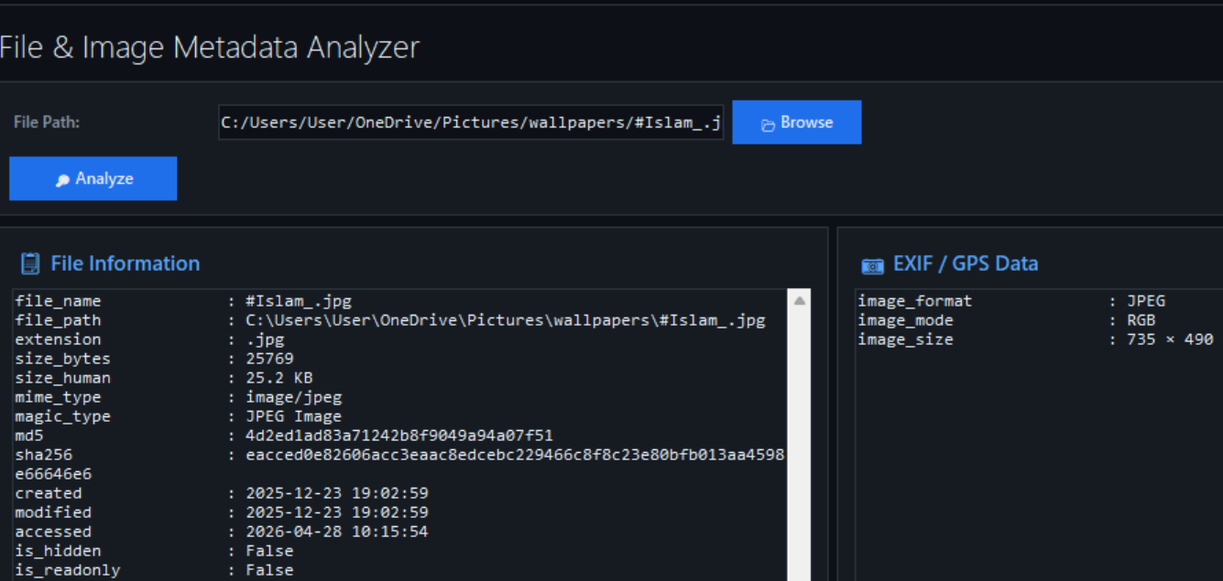

- Hash Verifier : This make sure that data is intact by using MD5, SHA-1 and SHA-256.

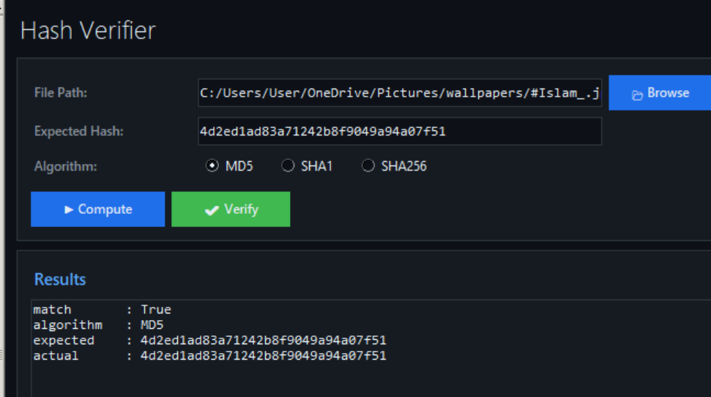

- Browser History Analyzer : It finds out what websites were visited and what was downloaded.
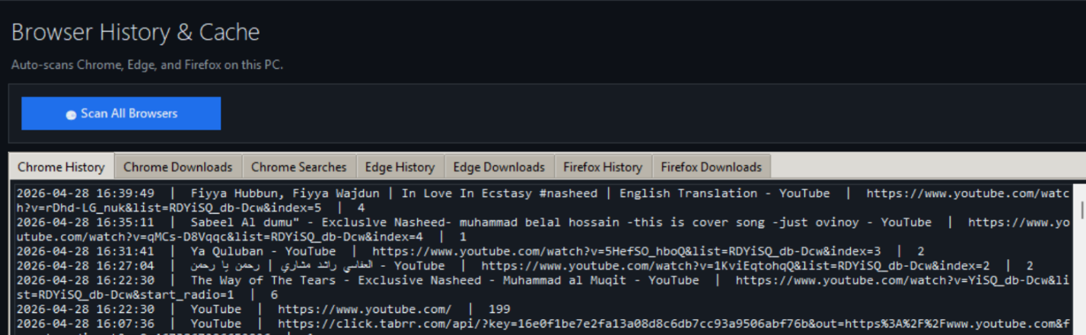

- Email Header Analyzer : This part checks if emails are fake and tries to find out where they came from.

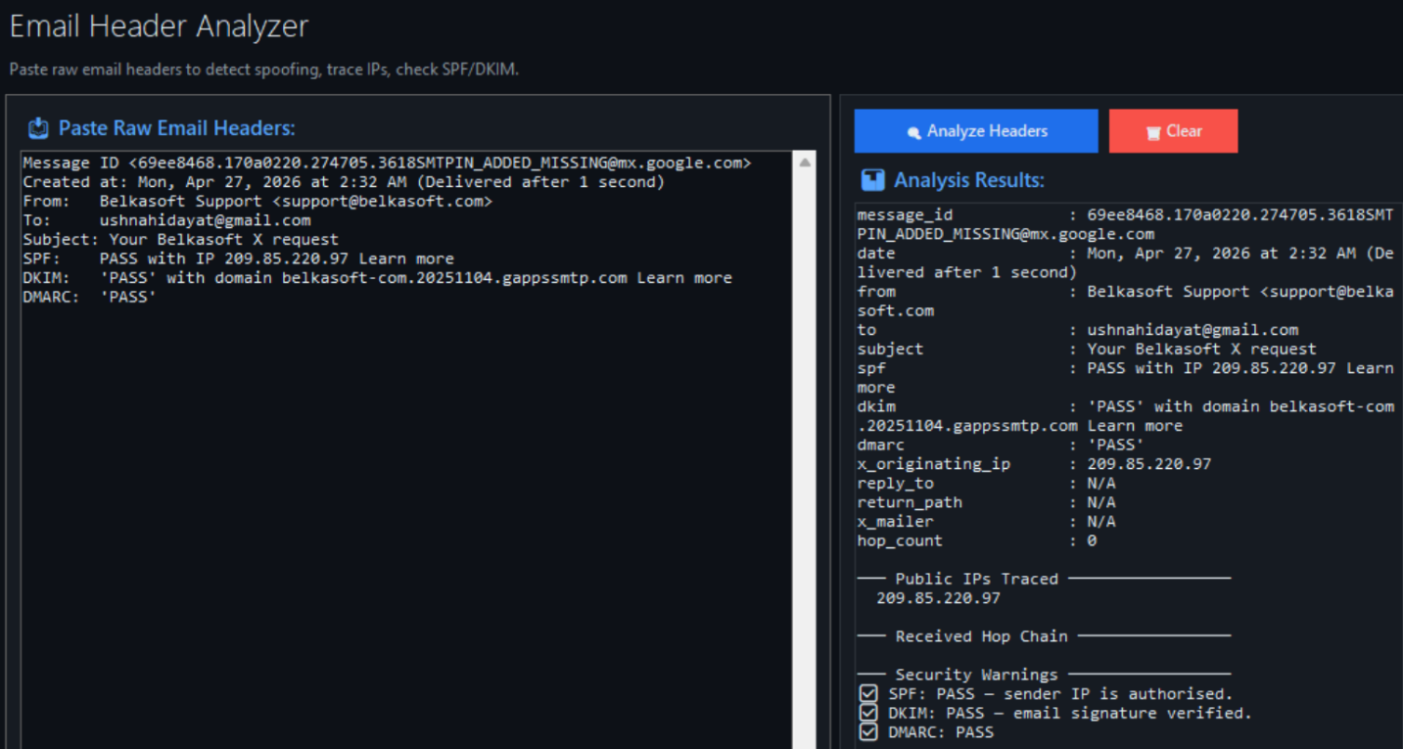

- Event log Parser : It looks at the security logs from windows .

- Steganography Checker : This finds hidden data in images.
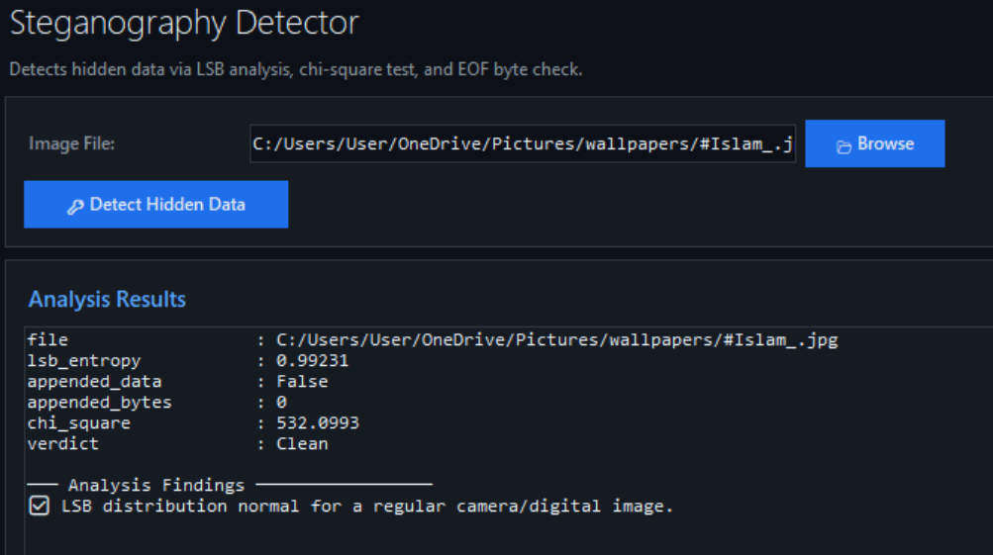
- Memory Dump Analyzer: It gets information from the mempry dump.

- Keyword search : This finds words inside files.
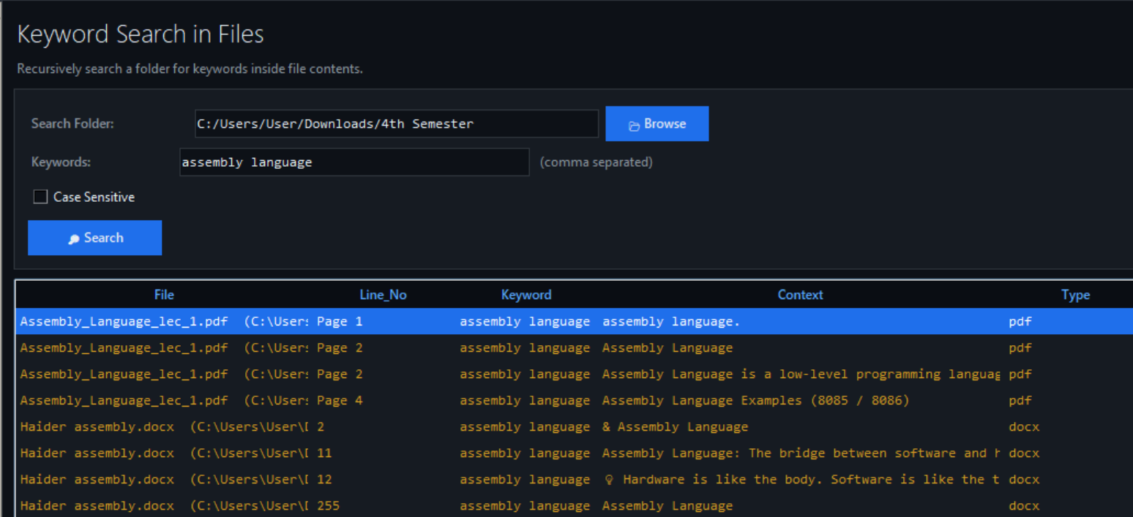

- Password Strength Checker : It checks how secure passwords are.
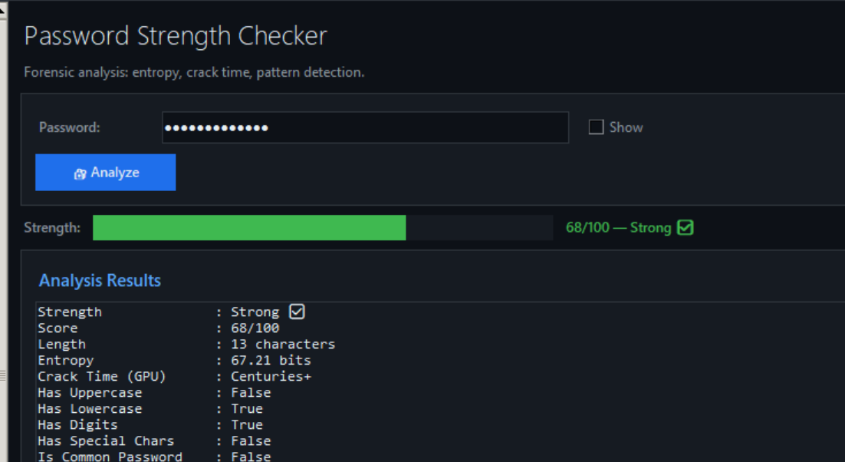

- Report Generator : It creates a professionl PDF report.

- Implementation :

We used technologies to build ForensiTrace:
- Python 3.12 for the core development
- Tkinter for designing the graphical user interface
- ReportLab for generating PDF reports
- Matplotlib for visualizing data
- Pillow for processing images
- SQLite3 for extracting data from browsers
- Hashlib for calculating hashes
Our system is built in a way. Each feature is a function. This makes it easy to maintain and add features.

- Testing :

We tested ForensiTrace with types of inputs:
- CSV files to analyze timelines
- Images to extract metadata
- Email headers to detect spoofing
- Browser data to analyze history
Here are the results:
- We successfully detected file extensions
- We extracted metadata from images, including GPS data
- We identified cases of email spoofing
- We generated PDF reports
- Our system performed fast with large datasets

- Conclusion :

ForensiTrace version 2.0 is an efficient solution for digital forensic investigations. It makes complex analysis tasks simpler. It reduces investigation time. Improves accuracy.
This system is especially useful for students and beginner investigators. It combines forensic tools into one easy-, to-use application. ForensiTrace helps users to investigate crimes effectively.

